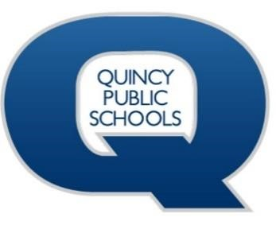

**DISTRICT IMPROVEMENT PLAN**

**2023 - 2024**

# STATE OF THE SCHOOLS

Quincy Public Schools District 172 has a clear district vision and mission that captures both the strengths and needs of the district in the present and future, while keeping students at the center with a goal that all students, teachers, and educational support professionals achieve their personal excellence. Transparency and accountability are strong tenants throughout the District Improvement Plan, with specific details as to the results of each Q-goal’s progress both at the school and district level that are presented throughout each year at the District Improvement Committee meetings.

The overall goal of the District Improvement Plan and Individual School Improvement Plans is to build systemic and sustainable capacity to carry out data-supported planning going forward. Planning helps prioritize major initiatives and may impact far-reaching areas including curriculum development, teaching, and learning, assessment, organization, facilities improvements, and data management.

During my first year as Superintendent, I concluded that while the district has many stakeholders supporting the daily work of educating our children, we must create a shared focus that carries our work through multiple years. In considering this it is crucial to hear all voices that we serve including students, staff, parents & caregivers.

The Quincy Public School District will improve student learning and system effectiveness by engaging in a cycle of continuous improvement to manage its performance. To support this purpose, we will be developing a multi-year District Strategic Plan to be presented to the School Board in the spring of 2024. The process to gather and create the multi-year strategic plan will be aligned to support schools, students, teachers, and educational support professionals in their performance management efforts. More information about the task of creating a multi-year strategic plan can be found in the “Focus for Excellence” section of this document.

The District Improvement Plan has been designed to meet local, state, federal, and program accountability requirements and must be evaluated and revised annually. The annual review of the District Improvement Plan is currently based on the components listed below. These components may be revised as we embark on creating a multi-year QPS Strategic Plan in the coming year. This plan will allow QPS to continue to foster relationships and build trust among our QPS families and community members. We will strive to provide equitable opportunities and resources for all students while promoting and supporting high-quality teaching practices that will provide a classroom environment that allows all students to learn and grow. Together, we will ensure that all students, teachers, and education professionals achieve their personal excellence.

With Blue Devil pride,

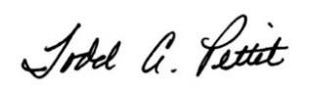

Dr. Todd Pettit, Ed.D., Superintendent

**QPS DISTRICT MISSION**

Educate Students and Teachers to Achieve Their Personal Excellence

# QPS DISTRICT VISION

The Quincy Public School District is committed to creating a culture of excellence in education for college and career readiness by:

Engaging students to **achieve personal excellence**;

Building professional knowledge and excellent teaching practices;

Utilizing curriculum aligned to the state standards;

Establishing high expectations and improving student growth; and developing active partnerships with parents and the community.

# FOCUS FOR EXCELLENCE

As a school district, we strive to support all students and staff in achieving their personal excellence. This includes a focus for excellence at the district level that guides the same focus at each school and each classroom. Our Focus for Excellence areas highlight our priorities in achieving our mission. Our district Q-Goals guide school leadership and staff to create School Improvement Plans that support the individual unique needs of each school while aligning to the larger focus and mission of the school district.

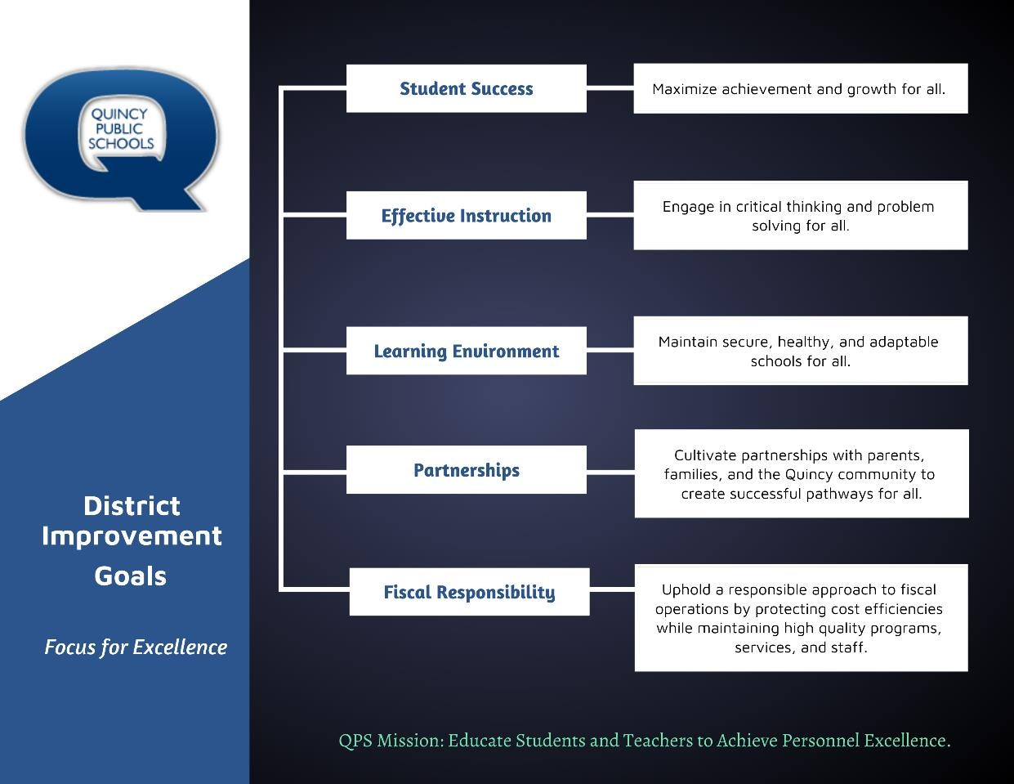

# 

# SUCCESSES TO CELEBRATE

* The Illinois 2022 School Report Card for QPS reported growth as QJHS improved state rating from Comprehensive to Commendable and Quincy Senior High & Rooney Elementary improved from Targeted to Commendable ratings respectively.
* We continue to show student growth through local MAP Assessment Data. This improvement did not note declines reported by other districts. A contributing factor for this improvement is that QPS remained open throughout the pandemic with both in-person and virtual learning.
* Quincy Public Schools continue to strengthen partnerships with Regional Office of Education#1, Thriving Minds (QMG & Clarity Healthcare), Bella Ease, Young Life, and John Wood Community College to name a few organizations that are committed to partnering to support students through academic advancement along with mental health and social emotional support.
* Extracurricular activities are paramount to developing the well-rounded student. Athletics, music & fine arts, FFA and other academic extracurricular offerings allow students the opportunity to get out of their comfort zone and experience life in meaningful ways. Both virtual and local field trips allow teachers to extend the classroom and experience learning in tangible ways.
* The Quincy Public Schools Foundation is among many financial contributors to allow QPS financial support to support teaching and learning. Local partnerships with these organizations and local corporations provide support in the areas of technology, athletics, and music & fine arts and to supplement a strained revenue stream.

# OPPORTUNITIES THROUGH CHALLENGES

* The Illinois 2022 School Report Card reported two QPS schools obtained a targeted status related to academic progress of Children with Disabilities. As mentioned in the previous section, three schools that were previously targeted allowed the district to focus resources on remediation for growth for these schools. It is evidenced that QPS has been successful through the IL Empower process as schools have now achieved commendable status. We anticipate the same focus and outcome to improve the education of our Children with Disabilities at two elementary schools.

* Filling open educator and educational professional positions in our climate today continues to be a challenge. The QPS Human Resources Department is dedicated to the recruitment efforts of new teachers while focusing on supporting educator and education professional well-being to increase job performance and retention.

* Nationwide schools report an increase in student disruptions at school. Addressing the needs of students is crucial as they navigate interacting with peers, understanding social norms and cues and maturity developmentally. Furthermore, typical adolescent development and growth was stunted for many students during multiple years in a pandemic environment. Support for students, teachers, educational professionals, and administrators is vital to maintain safe, healthy, and adaptable learning environments for all.

* An increase in chronic absenteeism is not simply a challenge for QPS, but for schools across the United States. Home and school connections are more important now than ever before. QPS is working to increase the capacity of teachers through the support and work of Student Support Family Liaisons (SSFL) at all grade levels, Social Emotional Student Support Managers (SE-SAMS) PreK – 8th grade and partnering with such programs as Thriving Minds to support the mental and behavioral health of students while supporting parents and caregivers.

# FUTURE FOCUS

The most recent QPS Strategic Plan was released during the school year 2013 – 2014. Our nine QPS educational communities have navigated many knowns, unknowns, challenges, and changes in education since 2014. By engaging in creating a current multiple year Strategic Plan, we will enhance our district focus and Q-Goals by building a plan that includes feedback from stakeholder groups, allowing the district goals to reflect current educational needs. A multi-year Strategic Plan will provide a positive forward momentum to guide and improve our work in our classrooms and school communities. Our work will continue to be aligned to school district improvement Q-Goals while providing school leaders, teachers, and educational support professionals the autonomy to meet the specific needs of each student in the classroom and the overall unique needs of each school community. We invite our community members and partners to remain engaged and involved as we work to co-support all students through the development of the QPS Strategic Plan during the 2023 – 2024 school year.

