**Quincy Public Schools District 172 has a clear district vision and mission that captures both the strengths and needs of the district in the present and future, while keeping students at the center with a goal that all students, teachers, and educational support professionals achieve their personal excellence. Transparency and accountability are strong tenets throughout the District Improvement Plan, with specific details as to the results of each Q Commitments' progress both at the school and district level that are monitored continuously at each school and presented three times each year at the District Improvement Committee meetings.**

**The overall goal of the District Improvement Plan and Individual School Improvement Plans is to build systemic and sustainable capacity to carry out data-supported planning going forward. Planning helps prioritize major initiatives and may impact far-reaching areas including curriculum development, teaching, and learning, assessment, organization, facilities improvements, and data management.**

**The district has many stakeholders supporting the daily work of educating our children, we must foster a shared focus that carries our work through multiple years. In considering this it is crucial to educate the community on the myriads of ways we support our students. It continues to be essential that all voices that we serve are heard and valued including students, staff, parents/caregivers, and community members.**

**The Illinois State Board of Education has set a goal of Continuous School Improvement processes for all schools and school districts. The Quincy Public School District will improve student learning and system effectiveness by continuing to engage in a cycle of continuous improvement to manage its performance.**

**The District Improvement Plan has been designed to meet local, state, federal, and program accountability requirements and must be evaluated and revised annually. The annual review of the District Improvement Plan is currently based on the components listed below. We will strive to provide equitable opportunities and resources for all students while promoting and supporting high-quality teaching practices that will provide a classroom environment that allows all students to learn and grow. Together, we will ensure that all students, teachers, and education professionals achieve their personal excellence.**

**With Blue Devil pride,**

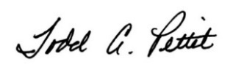

**Dr. Todd Pettit, Ed.D., SuperintendentQPS District Mission**

Educate Students and Teachers to Achieve Their Personal Excellence

**QPS District VISION**

The Quincy Public School District is committed to creating a culture of excellence in education for college and career readiness by:

**Engaging students to achieve personal excellence;**  
**Building professional knowledge and excellent teaching practices;**  
**Utilizing curriculum aligned to the state standards;**  
**Establishing** **high expectations and improving student growth; and**  
**Developing active partnerships with parents and the community.**

**FOCUS FOR EXCELLENCE**

Quincy Public Schools strives to support all students and staff in achieving their personal excellence. This includes a focus for excellence at the district level that guides the same focus at each school and each classroom. Our Focus for Excellence areas highlight our priorities in achieving our mission. District Q Commitments and Priories guide school leadership and staff to create School Improvement Plans that support the individual unique needs of each school while aligning to the larger focus and mission of the school district.

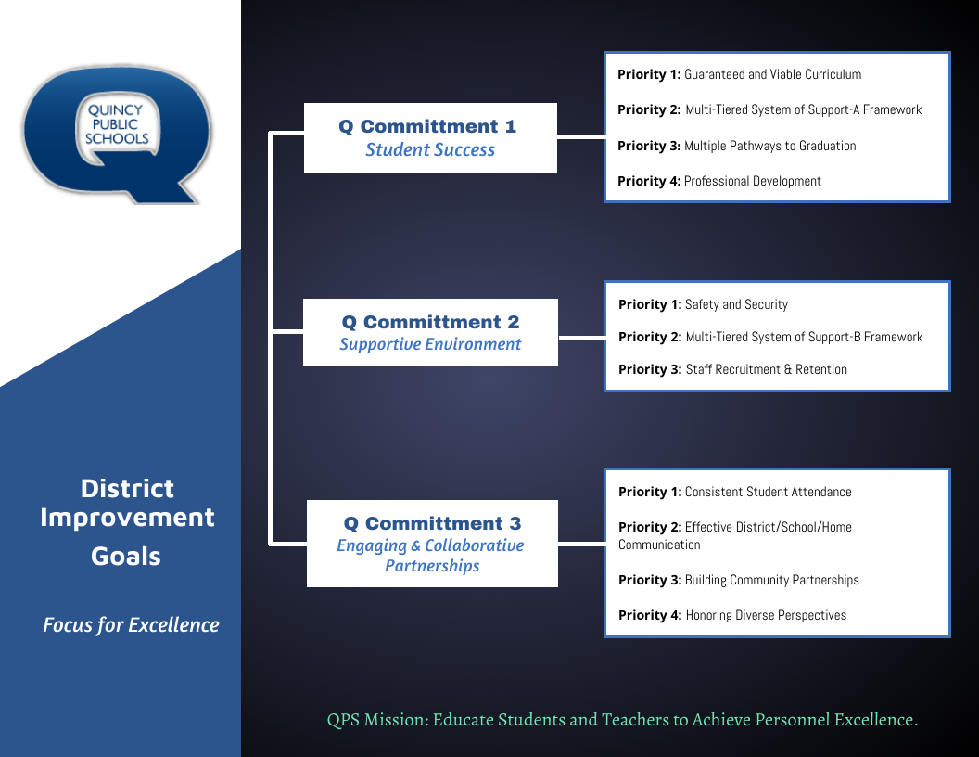

SUCCESSES TO CELEBRATE

* The Illinois 2023 School Report Card for QPS reported areas of improvement for QPS in academics. While proficiency rates show whether students have mastered a grade level standard set forth by the Illinois State Board of Education, student growth recognizes progress toward and beyond the standard, no matter where each student started. In academic growth, QPS experienced an increase from Spring 2022 to Spring 2023 for students in grades 3-8 who met learning expectations in Math on the Illinois Assessment of Readiness. (51.7% in Spring 2022 to 61.5% in Spring 2023). Data from the Illinois Report Card shows that QPS is closing the achievement gap in the academic performance of individual student groups. For example, the achievement gap between low-income students and non-low-income students was a difference of 26% in English Language Arts and 24% in Math in the Spring of 2022. In Spring of 2023, the achievement gap between low-income students and non-low-income students decreased to 23% in English Language Arts and 23% in Math. Each year, our Kindergarten students are observed for Kindergarten Readiness through the state required KIDS Assessment. Students are assessed on 14 measures across three developmental areas: Language and Literacy Development, Math, and Social and Emotional Development, during the first few weeks of school. In 2023, 95.7% of our incoming Kindergarten students were assessed and QPS students exceeded the state average in all three developmental areas. For our high school students, the 9th grade year is a critical year as students begin earning course credit to meet high school graduation requirements. Students who finish their ninth-grade year “on track” are almost four times as likely to graduate from high school as students who are not on track. In 2023, QHS reported 81.3% of high school freshmen as “on track”, meaning they earned at least five full year course credits and no more than one semester “F” in a core class. In addition to academics, the overall attendance rate increased from 2022 (88%) to 90% in 2023, while the overall Chronic Absenteeism Rate decreased from 36.1% in 2022 to 31.2% in 2023.
* We continue to show student growth through local MAP Assessment Data. The NWEA MAP Growth Assessment allows for measures of student achievement and growth at multiple times throughout the school year. The assessment is administered to students in grades K-10 in the Fall, Winter, and Spring, and it provides immediate results to individual teachers, school administrators, and district administrators so we can respond to the instructional and academic needs of students quickly as well as identify trends and gaps in curriculum and instruction that need to be addressed to ensure all students can succeed.
* Quincy Public Schools recognizes the rich learning opportunities that are available within our local community. As a district, we continue to strengthen partnerships with multiple community organizations to provide enriched learning experiences for all students, including the Quincy Public Library, Quincy Society of Fine Arts, Bella Ease, The Children’s Museum, The Historical Society of Quincy and Adams County, The Quincy Art Center, Quincy Community Theater, The Optimist Club, Breakfast Kiwanis, Young Life, John Wood Community College, LifePoint Church, and The Crossing.
* All certified and non-certified staff were trained in Trauma Informed Practices. The trauma informed training that took place over the past school year focused on the Neurosequential Model “Brain Model” based on the work of Dr. Bruce Perry (neuroscientist). The training offered was sustained training over time, so that educators could hear a small dose of how to help/teach students, with trauma or high stress, in and out of the classroom, and then apply what they learned.
* Extracurricular activities develop a well-rounded student. Athletics, fine arts, National Honor Society, Student Council, FFA and other extracurricular offerings allow students the opportunity to get out of their comfort zone and experience life in meaningful ways. A grass roots effort at Iles Elementary School to create an after school intramural opportunity was realized with great success. Partnerships with Quincy Park District and the school volunteer coordinator and administrator supported the successful outcome of the opportunity, so much so that the program goal is to expand to other elementary schools in the district during the 2024 – 2025 school year.
* Both virtual and local field trips allow teachers to extend the classroom and experience learning in tangible ways. Partnerships with Arts Quincy allowed hundreds of students to visit the Quincy History Museum on the Square, the John Wood Mansion, the Art Center, the Quincy Community Theater, the Quincy Children’s Museum, and the Quincy Public Library as the district received grants to cover the cost of transportation to the venues.
* The Quincy Public Schools Foundation is among many financial contributors to allow QPS financial support to support teaching and learning. Local partnerships with these organizations and local corporations provide support in technology, athletics, and music and fine arts, and to supplement a strained revenue stream.
* The Superintendent and Coordinator of Community Outreach presented a program titled “Supporting Quincy Public Schools Students” to seven community organizations during the spring and early summer of 2024. The learning visual below outlines the focus that when community supports schools, schools support students and students become productive citizens continuing the Q loop of student success.
* All district administrators and security staff were trained on the “I Love U Guys” standard response protocol during the 2023 – 2024 school year. The QPS Director of Security focused on creating a reunification process/protocol complete with materials needed in the event a reunification process is needed. All district staff have been educated on the updated protocols used at the school level. Next school year the Director of Security will work with area law enforcement and emergency management to organize a reunification simulation.
* Teacher Residency is a ‘Grow Our Own’ model for recruiting quality educators to QPS. Since the 2018-2019 school year, more than 50 teachers have been hired and placed in certified roles while completing their certification. QPS has partnered with Quincy University, Culver Stockton College, and Grand Canyon University to offer affordable flexible options for candidates who might be interested in a career in education. Throughout the year, QPS hosts presentations to recruit and build relationships with potential future teachers.

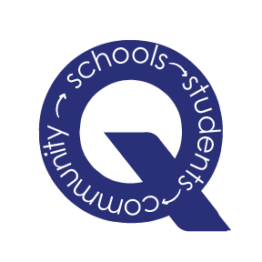

OPPORTUNITIES OF GROWTH THROUGH CHALLENGES

* The Illinois 2023 School Report Card reported that there are students underachieving in academics and social emotional learning. We recognize these deficiencies and work diligently to continuously refine our core systems and practices, increase student access to interventions, and provide professional learning opportunities for staff to ensure they are prepared to support all students to achieve their personal excellence.
* Filling open educator and educational professional positions in our climate today continues to be a challenge. The QPS Human Resources Department is dedicated to the recruitment efforts of new teachers while focusing on supporting educator and education professional well-being to increase job performance and retention.
* Nationwide schools report an increase in student disruptions at school. Addressing the needs of students is crucial as they navigate interacting with peers, understand and teach social norms and cues as they mature. Additionally, typical adolescent development and growth was stunted for many students during multiple years in a pandemic environment. Support for students, teachers, educational professionals, and administrators is vital to maintain safe, healthy, and adaptable learning environments for all.
* There is an increase in drug use, especially THC vaping among secondary students is on the rise. School, parent, and community support to reduce this epidemic is crucial. QPS Administration and the Board of Education in conjunction with the Discipline Committee will explore consequence options with the goals to 1) Keep students in school, 2) Address the THC use/addiction, 3) Educate the community, parents, and students on the importance of not having drugs on school campuses. Thriving Minds Substance Abuse counselors at QHS and QJHS have been an asset to addressing student substance abuse challenges. Additional substance abuse health resources are needed to address the number of students needing services.
* QPS forecasts a structural deficit in our operating funds by the end of fiscal year 2027-28. This deficit has been delayed due to federal COVID relief funds that began in 2020 and an increase in Corporate Personal Property Replacement Tax (CPPRT) from the State. Both revenue streams are ending. While our focus is on continuous improvement, the Board of Education will work with administration to support funding daily operations while focusing on maintenance and improvements to our facilities.

FUTURE FOCUS

Creating a multi-year Strategic Plan was a district goal during the 2023 – 2024 school year. Two teams were formed to embark on this work, a Strategic Plan Design Team, and Strategic Plan Data Analysis Team. While we are fortunate to have staff members who possess the knowledge to undertake each of these areas, the capacity to conduct market surveys among staff and the community was problematic. Upon analyzing the data from staff and parent surveys, it was clear that a broader representation of voices was needed. The team determined that to continue a strategic plan focus, we must know how the district will address deficit shortfalls in coming years. In the place of creating a multi-year strategic plan, the outcome was a beta test of the process, learning what capacity will be needed to develop an accurate and forward focus strategic plan. Further, it was determined that the yearly school improvement plans, and district improvement plans are annual commitments and priorities that keep the district moving forward.

**Community Engagement** & **Financial Outlook** were in the central scope of the superintendent and district administration during the 2023 – 2024 school year. The district projects a fund deficit by the end of fiscal year 2027-28. As such, the Board of Education charged the superintendent to engage the community in school funding and deficit reduction options. One community engagement meeting was held in spring 2024 with nearly 60 community stakeholders participating. The Board of Education determined upon this meeting's conclusion that there must be a pause in the Community Engagement process to align all members with it and clarify the purpose of the community engagement process. The superintendent in partnership with the Board of Education will determine the next steps with this process.

**Restorative Practice Training** will take place during the 2024–2025 school year and is based on the International Institute for Restorative Practices' work. The training will be offered as a Train the Trainer program for the Social Emotional Leaders in each building. The focus of the learning will be proactive approaches including Check in Circles, Non-Judgmental Language, preventing difficult moments between staff & students, and students & students. All staff will learn the continuation of the Neurosequential Model, aka Brain Model, that was taught last year including strategies to regulate students so that optimal learning and well-being of all students can be achieved.

**Professional Learning** for all staff is key to our continued success. This belief is rooted in our QPS tradition that educators are supported in their desire for professional growth and development. The QPS Mission and Vision reflect this belief as well. Each year, our professional development plan builds on professional learning from the previous school year to ensure all staff can build and enhance their learning around best practices for student learning. During the 2024-2025 school year, while all school staff will engage in professional learning around the topic of Restorative Practices, professional development at Early Childhood and Family Center will continue to focus on best practices for early learning and implementation of Conscious Discipline. At the K-5 level, professional learning will focus on implementing the new Literacy and Math Curriculum adopted in April 2024 and building community and culture through the Ron Clark House System. Quincy Junior High School and Quincy High School will continue to focus on course alignment to standards while ensuring teacher clarity and credibility, and The Academy, as an alternative/Regional Safe School Program, will engage in training on educational neuroscience to meet the unique and individualized SEL needs of the students they serve.

The number and variety of special education teachers who are participating in professional developments specific to their students' needs continues to increase.

**A Boundary Study** will be conducted during the 2024 – 2025 school year. The goal of this study is to assess enrollment numbers at K – 5 schools to even their distribution. The last study was conducted in 2015 during planning and construction of five new elementary schools. In the years since new housing developments have been constructed which has impacted enrollment at some schools.

School Improvement Q Commitments - 2024 – 2025

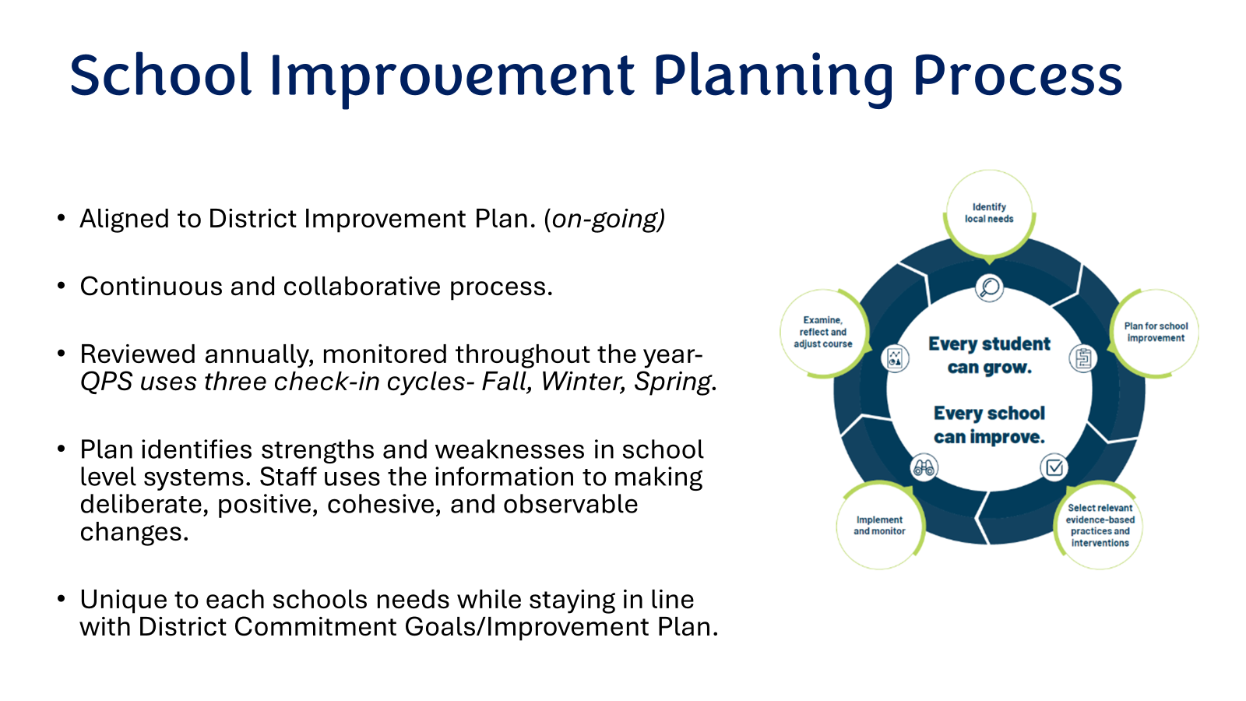

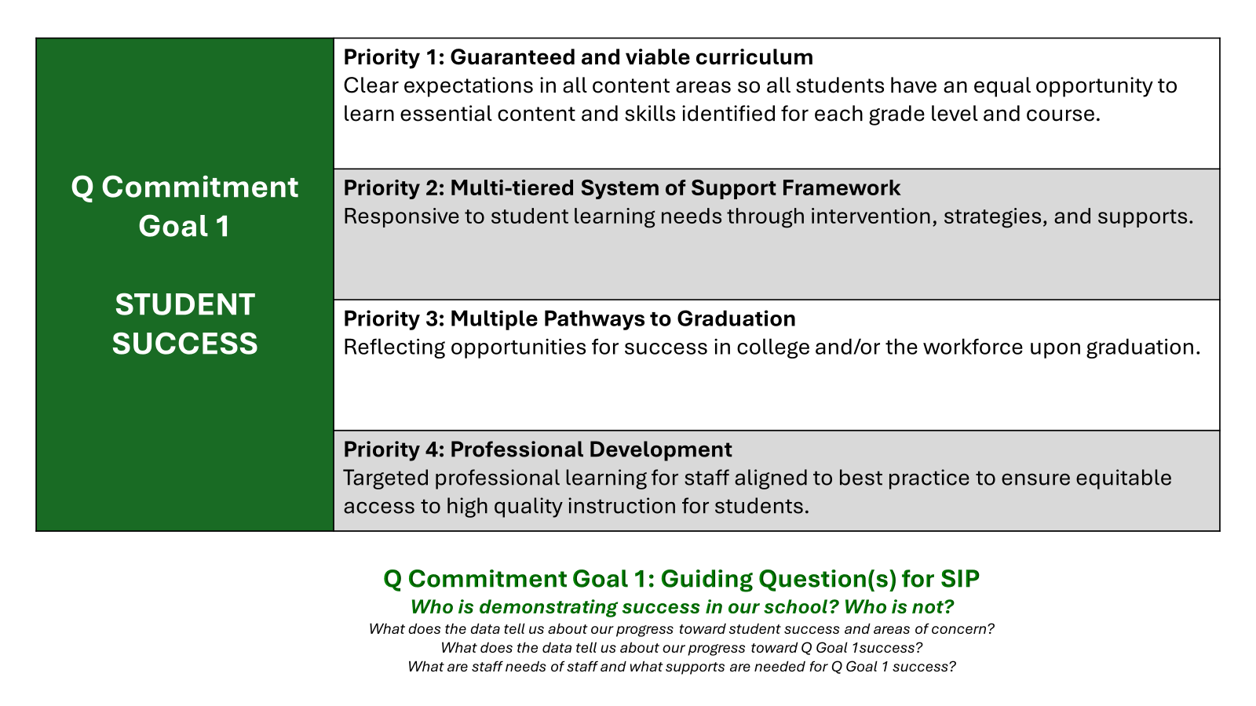

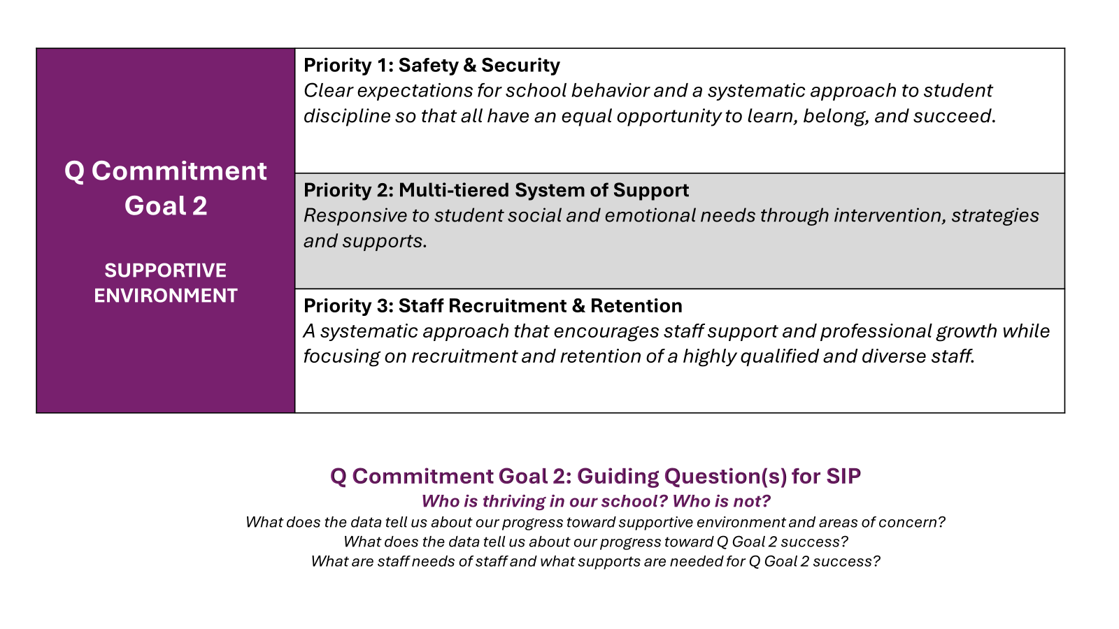

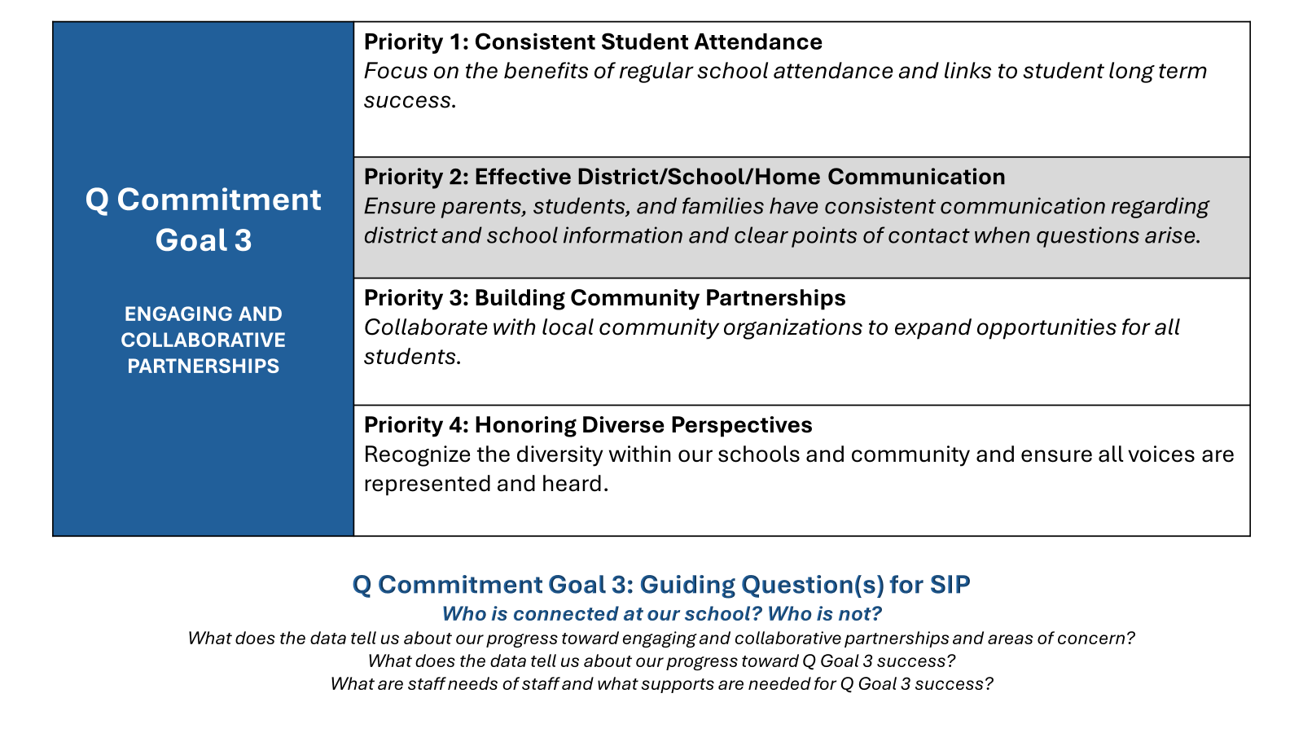

CONCLUSION

Our work will continue to be aligned to school district improvement Q Commitments and Priorities while providing school leaders, teachers, and educational support professionals the autonomy to meet the specific needs of each student in the classroom and the overall unique needs of each school community. We invite our community members and partners to remain engaged and involved as we work to support all students and staff.

