Request for Duplicate Diploma

If you are a graduate of Quincy Senior High School and have lost or misplaced your high school diploma, it is possible to order a duplicate diploma. The fee for a duplicate diploma is $20.00. A diploma cover may also be purchased for an extra $20.00. Payment must accompany this form before a duplicate diploma is processed.

Verification of your graduation date will need to be made. Please allow at least 7 to 10 business days for this service. Your driver’s license or a picture id that includes your birth date must be shown when picking up your diploma. If you authorize someone else to pick up your diploma, include a copy of your ID with this request.

- Current Information

Name: _________________________________________________________________________

Current Address: _________________________________________________________________

_________________________________________________________________

Daytime Phone Number Where You Can Be Reached: ___________________________________

Email Address: __________________________________________________________________

- Name as you think it appeared on your original diploma (PRINT)

_______________________________________________________________________________

- Identification

Date of Graduation: ______________________ Date of Birth: _______________________
Year Month / Day /Year

Mother’s Name: __________________________________________________________________

Father’s Name: __________________________________________________________________

- Authorization

I authorize ____________________________________________________ to pick up my diploma.

Signature of Graduate: ____________________________________________________________

Date: ______________________

Please return this form with your cash, check, or money order to:
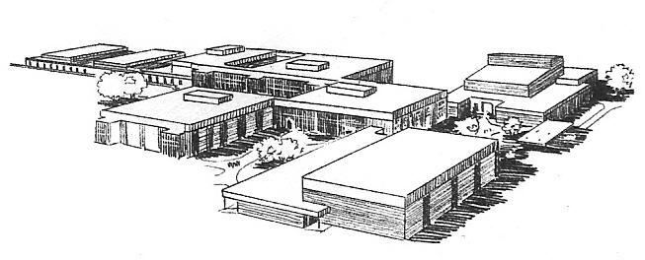
Quincy Senior High School
Candice Bartley
3322 Maine Street
Quincy, Illinois 62301
Quincy Senior High School
Attn: Debbie McNeil
3322 Maine Street
Quincy, IL 62301

