Benefits Newsletter
November 2021

IMRF Employees – NCPERS Voluntary Life Open Enrollment

The open enrollment for the NCPERS voluntary life insurance will run 11/8/21 – 11/30/21. The announcement letter, brochure of coverages and enrollment forms are located on the QPS website at www.qps.org, Human Resources, Benefits, Life Insurance. You can also contact Teresa Kemp at the BOE to receive these forms. If you are already enrolled in NCPERS you do not need to re-enroll. Please send your enrollment forms to Teresa Kemp by November 30, 2021.

BCBS Online Registration

We encourage you to register online with BCBS to manage your benefits. Go to www.bcbsil.com and set up your account to find providers, print and order ID cards, and view your claims.

TeleDoc

Please remember we have the Teladoc service available to all employees and family members who are covered by any of the QPS medical plans. This service provides a free consultation with a physician over the phone.

It’s a good idea to register with Teladoc BEFORE you need the service. If you are pre-registered, they will have all the information they will need to expedite your phone consultation with the doctor. You can contact Teladoc by mobile app, phone or online (instructions in the flyer attached to this email).

Air Evac Enrollment

Air Evac applications have been delivered to your building. If you wish to join or renew your membership, please contact Penny Roberts at 217-779-3744 or Penny.Roberts@amgh.us

Contact Information
Benefits Coord:  Teresa Kemp  228-7158 #2244  kempte@qps.org | SIC Officers:  Chair – Darla Rardon  Secretary – | BCBS Customer Care:  1-855-686-8517  Pharmacy:  1-800-423-1973 | QPS Website:  www.qps.org  “Human Resources”  “Benefits”

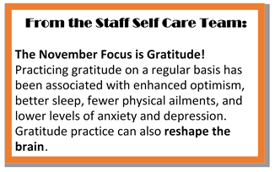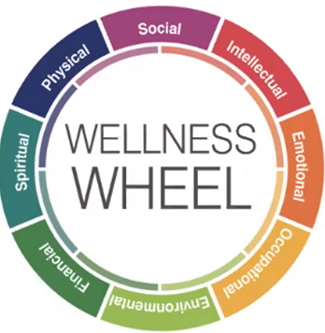
From the Staff Self Care Team:

The November Focus is Gratitude!
Practicing gratitude on a regular basis has been associated with enhanced optimism, better sleep, fewer physical ailments, and lower levels of anxiety and depression. Gratitude practice can also reshape the brain.

From the Staff Self Care Team:

The November Focus is Gratitude!
Practicing gratitude on a regular basis has been associated with enhanced optimism, better sleep, fewer physical ailments, and lower levels of anxiety and depression. Gratitude practice can also reshape the brain.

